Americans with Disabilities Act Advisory Committee

Public Notice of Meeting and Agenda
Thursday, September 18, 2025
Time: 1:30 p.m. – 3:00 p.m.
Location: City of Las Cruces City Hall, 2nd Floor
700 North Main Street
Las Cruces, NM 88004

AGENDA
- Call to Order
- Determination of a Quorum
- Introduction
- Approval of Agenda
- Approval of Minutes
- Old Business
  - Minutes follow-up
  - Follow-up for businesses
- New Business
  - Names of presenters
  - Social media plan
- ADA Committee Goals and Objectives
  - Goal 1
  - City ADA update
  - Goal 2
- Committee Member Input
- Public Comments/Announcements
- Adjournment

NOTE: The City of Las Cruces provides equal employment opportunities and does not discriminate based on race, sex, age, disability, or any other protected class in employment or the provision of services. Individuals may request reasonable accommodations and language accessibility services at (575)528-3100/TTY 711.

To assist the City’s efforts to accommodate people with severe allergies, environmental illnesses, multiple chemical sensitivity or related disabilities, we ask that all participants limit chemical-based products. Please help the City accommodate these individuals.

Posted: 9/8/25

Americans with Disabilities Act Advisory Committee Attachments Follow

Unofficial Meeting Minutes. July 17, 2025. Official signed meeting minutes will be available with the City Clerk by September 30, 2025.

MINUTES
ADA ADVISORY COMMITTEE
Thursday, July 17, 2025
Time: 1:30 p.m. – 3:00 p.m.
Location: City of Las Cruces City Hall, 2nd Floor - Room 2305
700 North Main Street
Las Cruces, NM 88004
- Call to Order: The ADA Advisory Committee meeting was called to order by Chair, Maureen Gant at 1:30 p.m.
- Determination of a Quorum: A quorum was present.
- Introductions: All individuals present introduced themselves. Jennifer Dahlgren is a member and was absent. Six (6) members of the public were present.
- Approval of Agenda: Maureen Gant asked for any changes to the agenda. Having no changes, a motion was made by Susana Santillan and seconded by Isaac Taylor-Wise to approve the agenda as written. Motion carried with all committee members present voting aye.
- Approval of Minutes: The minutes were sent out in advance of the meeting, so the reading of the minutes aloud was omitted by unanimous consent. Maureen Gant asked for any corrections to the minutes. Having no corrections noted, a motion was made by Sharon Roybal and Susana Santillan seconded by to approve the minutes as written. Motion carried with all committee members present voting aye.
- Old Business - None
- ADA Committee Goals and Objectives
  - Goal 1 Maureen Gant: Update City of Las Cruces ADA Transition Plan by: (a) continuing to track improvements to city buildings, facilities and public right-of-way, parks, and trails, (b) providing input and recommendations on priorities for ADA compliance, and (c) providing an opportunity for interested persons to participate in the development of the transition plan by submitting comments identifying barriers that may exist for persons with disabilities in accessing city-sponsored facilities or programs.
    - See Committee Attachments for report. Attached.
  - Goal 2: Monitor emerging ADA laws, regulations, and policies for updates.
    - See Committee Attachments for report. Attached.
- New Business – Calendars, social media events and articles
- Presenter – Saron McKee provided a presentation about the ADA Transition Plan
- Committee Member Input: None
- Public Comments/Announcements: None
- Adjournment: The ADA Advisory Committee meeting was adjourned by Chair, Maureen Gant at 3 p.m.

____________________________________________ _____________________________
Susana Santillan, Secretary Date

Goal 1

Update City of Las Cruces ADA Transition Plan by: (a) continuing to track improvements to city buildings, facilities and public right-of-way, parks, and trails, (b) providing input and recommendations on priorities for ADA compliance, and (c) providing an opportunity for interested persons to participate in the development of the transition plan by submitting comments identifying barriers that may exist for persons with disabilities in accessing city-sponsored facilities or programs.

Department | ADA Elements of Project | Project Location | Location Details | Estimated Completion Date | Completion Date
Public Works | ADA curb ramps, sidewalk | Ardis Drive | Don Roser Dr. Covina Blvd | 7/31/2024
Facilities | ADA painting, signage, and restriping | Parking Lot #4 |  |  | 7/19/2023
Facilities | ADA painting, signage, and restriping | Parking Lot #6 |  |  | 9/8/2023
Facilities | City Staff ADA Access Elevator | City Hall |  |  | 10/20/2023
Facilities | ADA Door Openers | Museum of Nature and Science |  |  | 10/31/2023
Facilities | ADA Door Openers | Visit Las Cruces |  |  | 10/31/2023
Facilities | ADA Door Openers | Council Chambers |  |  | 11/1/2023
Facilities | Parking Lot ADA Ramp Repairs | City Hall |  |  | 12/19/2023
Facilities | Parking Lot ADA Ramp Repairs | Munson |  |  | 1/10/2024
Facilities | Parking Lot ADA Ramp Repairs | Henry Benavidez |  |  | 1/10/2024
Facilities | Parking Lot ADA Ramp Repairs | LC Convention Center |  |  | 1/19/2024
Facilities | Sidewalk Replacement and Ramp | Frank O’ Brien Papen Center |  |  | 1/19/2024
Facilities | Sidewalk and Basketball repair | Weed and Seed |  |  | 1/26/2024
Facilities | Sidewalk and Rail repair | Meerscheidt |  |  | 1/30/2024
Facilities | Ramp Access | Rear of Library |  |  | 1/31/2024
Facilities | Downtown Sidwalk Paver Repairs | LC |  |  | 1/31/2024
Facilities | Restroom Counter Hand Soap | City Hall |  |  | 4/2/2024
Facilities | Jardin de los Ninos Cabinet and Roof Improvements |  |  |  | 4/3/2024
Facilities | ADA Latching Mechanism | Council Chambers |  |  | 4/10/2024
Facilities | Jardin de los Ninos Front Door Repair |  |  |  | 4/12/2024
Facilities | Changing Tables | RGT |  |  | 4/18/2024
Public Works |  | Telshor Blvd
Public Works | ADA curb ramps | Sandigale Drive | Delano Drive to Crestview Drive | 7/31/2024
Public Works | ADA curb ramps | Dr. King Way | S Walnut Street to Stull Drive | 7/31/2024
Public Works | ADA curb ramps | Monte Vista Ave | S. Solano Drive to South Locust Dive | 7/31/2024
Public Works |  | Bellamah Drive | Lees Drive to Luna St | 6/1/2024
Public Works | Sidewalk, ADA curb ramps | Campo Street |  | Fall 2025
Public Works | ADA curb ramps | Casa Linda
Public Works | ADA curb ramps, Sidewalk, Drivepads | Cortez Dr
Public Works | ADA curb ramp, Sidewalks, Drivepads | Madrid Ave | Evelyn St to Triviz Dr | 8/1/2025
Public Works | ADA curb ramps, Drivepads, sidewalk | Midway Ave | Gas Line to Mesa Drive
Public Works | ADA curb ramps, drivepads, sidewalk, crosswalks | S Main St | Avenida de Mesilla to Boutz | 7/1/2025
Public Works |  | Sonoma Ranch Blvd | Sierra Vantana to Peachtree
Public Works | ADA curb ramps, sidewalk |  |  | 7/31/2024
Public Works | ADA curb ramps, Drivepads, sidewalk |  |  | Winter 2024
Public Works | ADA curb ramps, sidewalk |  |  | Spring 2025
Public Works |  | Medpark Ave | Idaho to Pekins | Fall 2025
Public Works |  | Amador Dental Clinic |  | 60% completed
Public Works |  | Parking Lot 7
Public Works |  | Municipal Service Center |  | 60% Completed
Parks and Rec |  | Playground |  |  | 3/22/2024
Parks and Rec |  | East Mesa Public Recreation Complex
Parks and Rec |  | Young Park
Parks and Rec | Additional parking spaces will be built with an additional entrance to the parking area. | Northwest side of Veterans Memorial Park
Parks and Rec | Enhance pedestrian and bicycle safety by improving infrastructure | Walnut, Kilmer, Poplar, Madrid Ave.
Parks and Rec | Demolition of aged swings, slide and safety surfacing. New play equipment, safety surfacing, and benches will be installed. | Gallagher Park | 137 W. Gallagher Ave ad Nina’s Place
Parks and Rec | City Council approved master plans for Tony Gomez, Frenger Parks and Branigan Park. The master planning effort to develop a vision for the overall, long-range development of the three parks. | Tony Park, Frenger Park, Branigan Park
Branigan Library | Handicapped accessible stall- the toilet seat protector is empty and falls off the wall. | 2nd floor women's restroom | WO # 612016. |  | Completed
Branigan Library | The printer table is too high - The problem is the table itself is hard wired into electricity, and therefore cannot be moved. | Computer Lab | Plan to fund next fiscal year. Remove and replace with a lower table.
Branigan Library | Book stacks are too tall and may be too close together | Stacks | Looking at new book shelves- possibly a renovation
Branigan Library | Railing in the stairwell is loose. Reported several times during safety walk-throughs in the past. | Stairwell | Has a work-order been entered?
Branigan Library | Need an evacuation chair. | Stairwell | Is this in the plans?
Branigan Library | Library installed new book return system that is accessible. | Front of library |  |  | Completed

City ADA update

Advise the ADA Advisory Committee about updates to the City ADA Transition Plan.

The City is entering into a contract with WTG to start Phase II of our self-evaluation.
Phase I evaluation is complete. The City is creating a plan to address the areas of non-compliance.
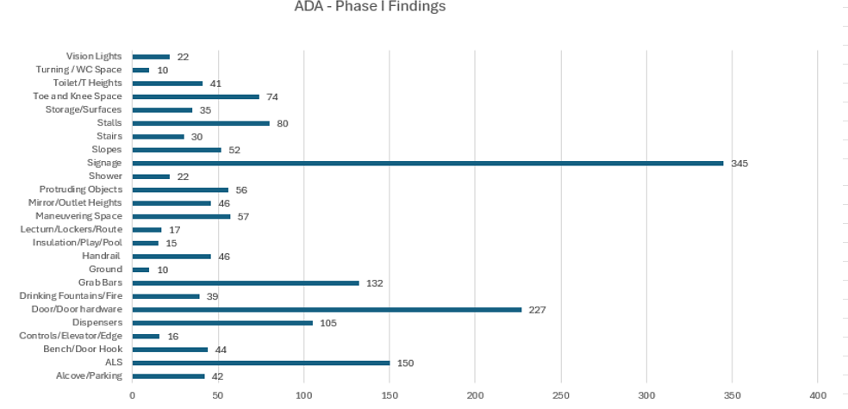

Goal 2

Monitor emerging ADA laws, regulations, and policies for updates.
U.S. Supreme Court declines to review ADA website accessibility case (August 2025) Acheson Hotels, LLC v. Laufer, 602 U.S. ___ (2025). [Supreme Court denial of certiorari on ADA website accessibility].
The Supreme Court let stand a lower court ruling requiring businesses to make their websites accessible to blind users under the Americans with Disabilities Act (ADA). This solidifies a growing body of case law recognizing digital spaces as “places of public accommodation.” Businesses must ensure screen-reader compatibility and other accessibility measures.

EEOC v. FedEx Ground – Employment disability discrimination (July 2025) EEOC v. FedEx Ground Package System, Inc., 75 F.4th 210 (3d Cir. 2025).
A federal appeals court upheld a $2.4 million verdict against FedEx Ground for failing to provide reasonable accommodations to deaf package handlers during safety training. The court reaffirmed that employers must provide effective communication methods (such as ASL interpreters or captioning) to comply with the ADA.

Massachusetts Court – Housing discrimination (June 2025) Smith v. Green Realty, 492 Mass. 120 (2025).
The Massachusetts Supreme Judicial Court ruled in favor of a tenant with a mobility impairment who sued her landlord for refusing to install a wheelchair-accessible ramp. The decision emphasized that landlords must provide reasonable modifications when requested, unless it causes undue financial or administrative burden.

California Court of Appeal – Service animals in schools (September 2025) Doe v. Riverside Unified School District, 98 Cal. App. 5th 342 (2025).
A ruling in California clarified that public schools must accommodate students with psychiatric service animals, not just physical disability-related animals. The court found that a school district violated both the ADA and Section 504 of the Rehabilitation Act by denying access to a student with PTSD who relied on a trained service dog.

